

Found this image on plularsight

In java we have basically two types of packages

1. User defined packages
2. Inbuilt packages

User defined packages are those folders that we create under which there are various java files

Here in user defined packages to work with any class present in any user defined package first we need to import it

There are also various inbuilt packages in java

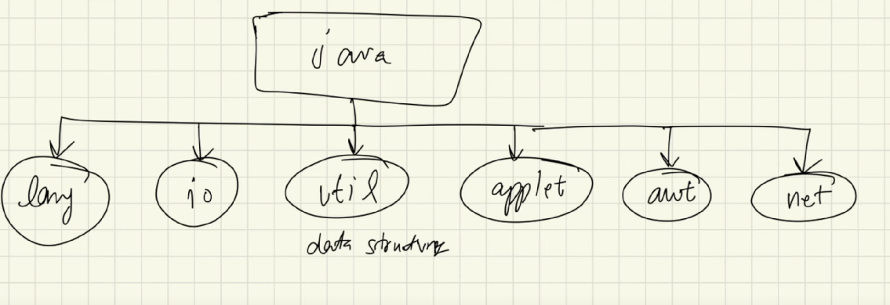

These are the few popular standard inbuilt packages in java

For the most essential and very basic inbuilt packages we do not need to import like in user defined packages

**How to know whether an object is an instance of a class or not ?**

We have an instanceof property which is really useful to check whether an object is an instance of a particular class or not

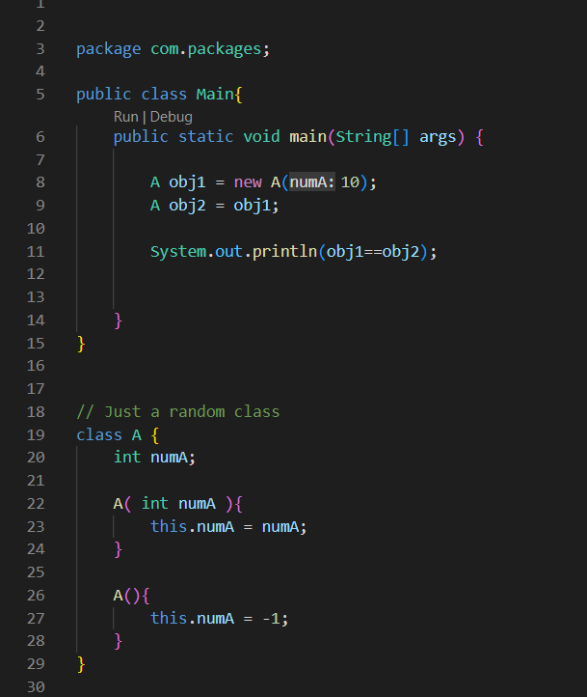

**== in java for user defined classes and objects**

Here == just checks whether there is same reference on both sides of the equals to

Here obj1 is just a reference variable living in stack that points to the actual object created during run time that lives in the heap

So if both of the references are pointing to the same object in the heap, then only they both are equal Than only == gives true value else it gives false value

**Instanceof property in java**

It is use to check whether an object is instance of a class or not

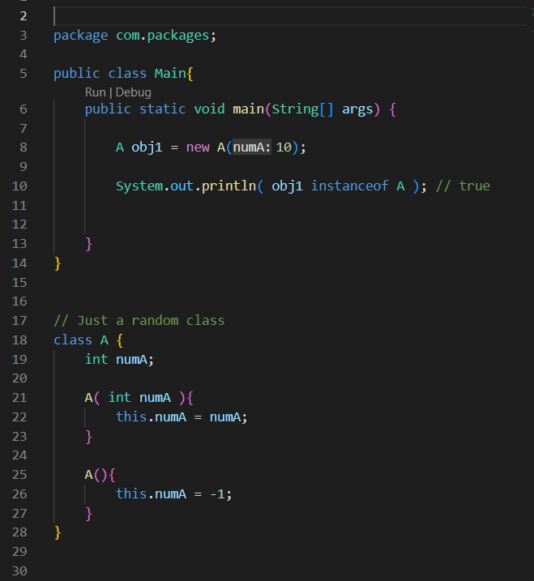

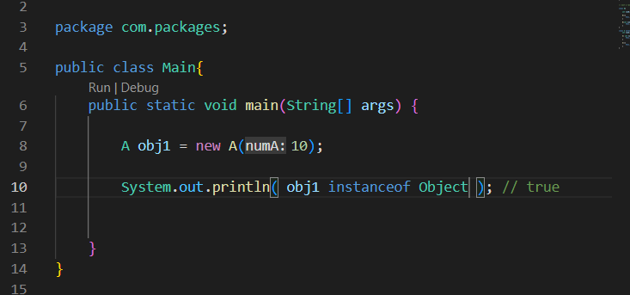

This shows every object is an instance of object class

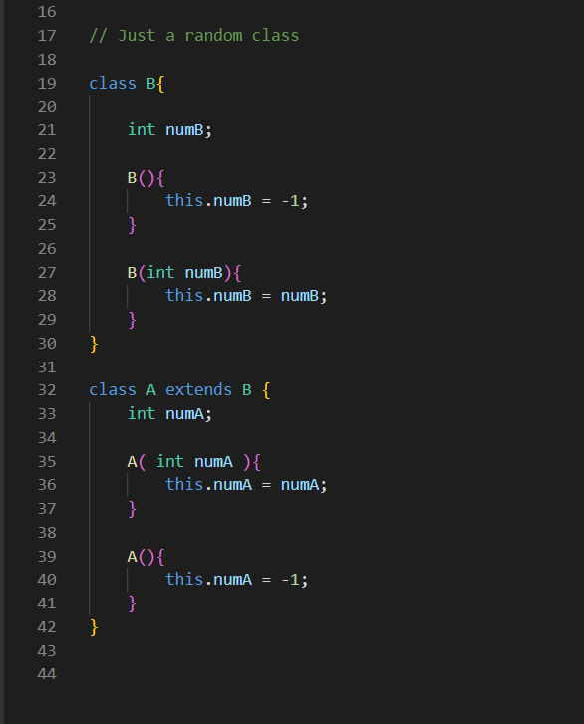

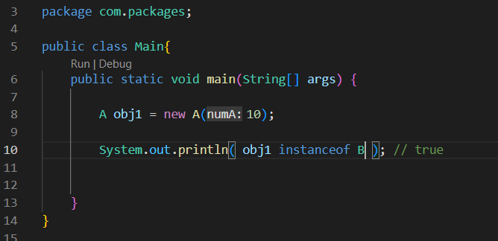

This shows that the object of child class is also an instance of parent class

**If we need to know the information about the class of any object**

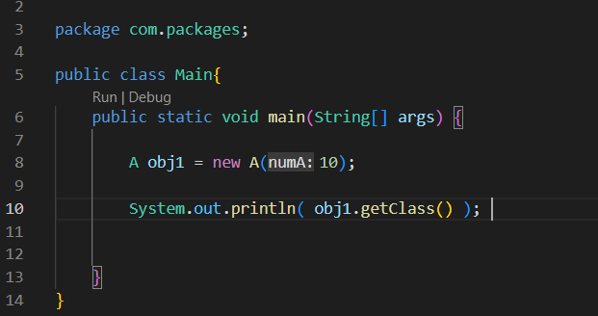

We have object_name.getClass( )

We even have other methods after this

